OPEN LETTER TO KEITH BEZANSON, PARTNERSHIP REVIEW COMMITTEE

15 October 2003

Dear Keith

It was useful for Sagari Ramdas, Devinder Sharma and myself to have been able to speak with you directly. As promised, I have put down a few ideas, many of which we discussed. I hope you will find them helpful as you develop your report for AGM 03.

In summary, we are concerned that the CGIAR finds ways to negotiate involvement of Farmers Organisations and Civil Society in the decision making structures at system level. However, reinstating the NGOC will not achieve this. The CGIAR needs to negotiate with independent and self-organised institutions that have global credibility and representativity among farmers and civil society organisations. A minimum objective of such negotiations should be to include farmers’ organisations in the system level decision making bodies of the CGIAR, on terms that are acceptable to them. Secondly, to restore its shattered credibility with Civil Society and Farmers organisations, the CGIAR must, with immediate effect, give priority to the key issues raised by the NGOC last year. The most urgent of these is the increasing contamination by GMOs of the Centre of Maize Diversity in Mexico and the leakage of material to the private sector from its gene banks, through allowing IPRs on some of the material and the genes it contains. AGM 03 will be a good opportunity to announce this.

The CGIAR is the only global agricultural research system with a mandate to produce public goods that will benefit the poor. Its combined activities are small, though, compared with private sector corporations, especially the Life Sciences transnationals, and the public sector agricultural research establishments of larger countries such as China, India or Brazil. With talk of merging or moving Centres, rationalising and retrenching, maybe some consideration should be given to the original idea of returning ‘mature’ centres to the agricultural research systems of the countries in which they are located. Whatever the outcome of the current reforms, global priority setting will still be crucially important to ensure that the limited efforts of the CGIAR are directed to deliver socially useful public goods that will sustain the livelihoods of the poor and protect the environmental and genetic resources they require.

The experience of many Civil Society Organisations working on food and agriculture and rural development is that the quality of decisions and their relevance improves with increased, decisive involvement of the intended beneficiaries – the smallholder farmers, herders/passtoralists, artisanal fisherfolk, Indigenous Peoples and others who manage the resources that produce the food for a large proportion of the world’s poorest people. It is also the experience of CSOs that, given appropriate support within a constructive policy and trade environment, these producers will also safeguard the natural resources on which their long-term survival depends. Life and livelihoods are sustained.

At present, the interim Science Committee has system-wide responsibility for priority setting but appears more influenced by ‘high science’ and funding opportunities to support this than poor producers’ needs and demands. There are honourable exceptions, some supported by NGOs, but overall, and especially at system-level, the CGIAR appears to have lost its commitment to inclusive pro-poor research. It also seems increasingly unable to respond effectively to the challenging issues raised by Civil Society and the demands of smallholder farmers’ organisations.

The CGIAR set up its NGO Committee (NGOC) in 1995 at the Luzerne meeting and successive members of that committee have tried to fulfil the mandate given to them by the CGIAR. The NGOC was set up under the CGIAR with its membership appointed by the CG Secretariat. It was never independent and this was its main failing and at the root of the problems of the CGIAR’s system-level relationships with Civil Society.

Prior to AGM 02 the NGOC reviewed the performance of the CGIAR and found it seriously deviating from its principal mandate and veering towards the corporatisation of agricultural research. The NGOC concluded that it was no longer willing to be directly associated with these failures and the NGOC ‘froze’ its relations with the CGIAR at system level. (See note from the NGOC to AGM02). Subsequently, the CGIAR secretariat announced a review of its Partnership Committees (including the NGOC) and a report is expected at AGM03 that will make recommendations about future relations between the CGIAR and Civil Society.

To move forward will require, at the least, some constructive response by the CGIAR at system level to the repeated observations, concerns and demands of Civil Society and Farmers’ organisations. Not only has the NGOC been critical of the policies, priorities and performance of the CGIAR, but so too has the wider community of CSOs and farmers organisations, as articulated, for example by Forum for Food Sovereignty in Rome in June 2002 which was the culmination of a process involving more than 2000 organisations worldwide.

An indication of significant changes in the governance of the CGIAR at system level, with priorities set through inclusive, deliberative and democratic decision-making by small-scale producers, could be one step forward. Also, a commitment by the CGIAR at system level to address the key raised by Civil Society and farmers’ organisations over recent years. Furthermore, an exclusive focus on generating public domain research outcomes and protecting the global public goods in their care (i.e. the Centre’s genebanks), that would provide a countervailing force to the research, extension and market influences of the corporate sector, would restore some confidence – for example, a principal priority on pro-poor, agroecological systems that can be controlled by farmers and which deliver not only food and income but also social, cultural and environmental goods, including biological and ecosystem services..

In terms of the governance of the system as a whole, the CGIAR Centres at national and regional levels would need to implement a matching commitment to change with steps taken towards ecoregional research centres, as outline in the Declaration for Durban.

Other fora, for example GFAR, will contribute their views on agricultural research but this forum cannot substitute the democratic involvement of farmers and their organisations in the governance of the CGIAR, nor the involvement of the wide range of Civil Society Organisations concerned with food and agriculture. The GFAR itself has a structure made up by nine “stakeholder groups” in each of five regions, in which ‘farmers’ play a minor role, and is caught up in representativity problems rather than providing a forum for open debate. It invariably covers up rather than exposes diverging opinions and it does not challenge the CGIAR.

The CGIAR needs the support and involvement of farmers as well as Civil Society Organisations, in order to deliver on its mandate. Without their commitment to interact and participate in the research programmes of the CGIAR, little of value will be achieved. It is therefore incumbent on the CGIAR to negotiate involvement with Farmers Organisations and Civil Society Organisations and not try to make them subservient to them. An objective of such negotiations should be to include farmers organisations in the decision making bodies of the CGIAR, on terms that are acceptable to them.

In summary, we are concerned that the CGIAR finds ways to negotiate involvement of Farmers Organisations and Civil Society in the decision making structures at system level. However, reinstating the NGOC will not achieve this.

The CGIAR needs to negotiate with independent and self-organised institutions that have global credibility and representativity among farmers and civil society organisations. A minimum objective of such negotiations should be to include farmers organisations in the decision making bodies of the CGIAR, on terms that are acceptable to them.

Secondly, to restore its shattered credibility with Civil Society and Farmers organisations, the CGIAR must, with immediate effect, give priority to the key issues raised by the NGOC last year. The most urgent of these is the increasing contamination by GMOs of the Centre of Maize Diversity in Mexico and the leakage of material to the private sector from its gene banks, through allowing IPRs on some of the material and the genes it contains. AGM 03 will be a good opportunity to announce this.

Finally, I would like to inform you that the International NGO/CSO Planning Committee (IPC) that has special relations with the FAO for the following up to the World Food Summit and the Forum for Food Sovereignty has a working group focused on agricultural research. This working group is giving priority to identifying the types of research that would deliver the outcomes demanded by the Forum for Food Sovereignty. It is also considering how civil society and farmers organisations can respond to international and regional agricultural research bodies. The CGIAR should be advised to keep close to the developments of this IPC working group.

I trust this will assist in your deliberations and the production of your report for AGM03.

Yours sincerely

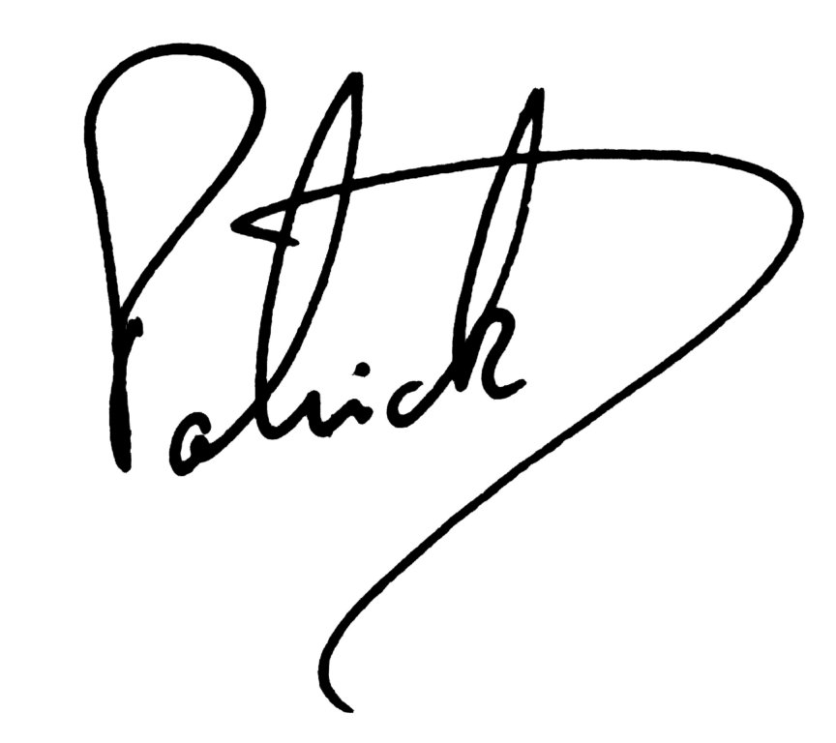

Patrick Mulvany
cc: Sagari Ramdas, Devinder Sharma

ITDG, (Intermediate Technology Development Group)
Schumacher Centre
Bourton, RUGBY
CV23 9QZ, UK

Subsequently the term ‘Farmer’ or ‘Farmers’ will be used in this letter to include all those who produce and harvest crops as well as livestock and aquatic organisms. ‘Farmers’ include smallholder peasant/family farmers, pastoralists, artisanal fisherfolk and Indigenous Peoples, among others.

