World Food Day @ European Social Forum 16th October 2004

Seminar 4.30 – 6.30 pm Alexandra Palace, Event number 2025

Food Sovereignty, Fair Trade and Diversity:
challenging corporate control

Speakers:

Jennifer Mourin, PAN-AP (Pesticide Acton Network Asia-Pacific), Malaysia
Maria Carrascosa, Plataforma Rural, Spain

Victor Campos, Centro Humboldt, Nicaragua, a partner of CIIR
Davuluri Venkateswarlu, GLOCAL, India, a partner of ActionAid
Fabienne Kervarec, Artisans du Monde, France

Alberto Zoratti, ROBA dell’Altro Mondo, Italy
Claude Giraud, CPE (Coordination Paysanne Européenne), France
Patrick Mulvany, UK Food Group / ITDG, UK (Facilitator)

The seminar championed smallholder farmers’ organisations and CSOs’ demands for international recognition of the right to Food Sovereignty, and challenged the dominance of WTO and multi-national corporations that feed profits not people. Speakers promoted fair trade, regulation of agri-food businesses, local control of natural resources and diverse, GM-free agroecology and agricultural biodiversity. There was also strong condemnation of FAO for promoting GM crops for the poor.

There was general agreement among participants that a new policy option, food sovereignty, was urgently required not only to end the hunger facing 842 million people every day but also to enable farmers to survive, both in Europe and the Global South. In Europe, one farm disappears every minute of every day; in India, hundreds of millions of farmers will lose their farms this decade. Farmers provide a diversity of nutritious food for local markets as well as living landscapes and life support systems – ecosystem services – and they maintain this diversity through conserving seeds and livestock breeds and developing agroecological farming systems.

Governments were denounced for aiding the corporatisation of agriculture and agricultural trade through the rules of the WTO Agreement on Agriculture and structural adjustment policies, which are fiercely challenged by their own citizens and many other governments in the Global South. Yet, for the 90% of the food that isn’t traded globally, these international rules have hastened the destruction of local farming. Participants criticised WTO trade rules that have supremacy over fundamental rights of people and environmental integrity. Participants called for an end to the dumping of cheap food imports on local markets.

There was a strong call for increased support for small-scale agriculture and farmers, not just for the sustainable production of a wide diversity of foods for local markets, but also to conserve and protect rural communities in all countries. Local markets need to be prioritised over national and international markets wherever possible, to allow people access to the food they want, to stimulate the local economy and support local farmers and to safeguard the environment.
Key points of agreement:

- Agriculture should come out of WTO. The CAP needs to be changed in favour of small-scale farmers.
- We join with world social movements in fighting for Food Sovereignty including the Right to food, the rights of all local communities for access to and control over the diversity of local natural resources, to use sustainable (agroecological) farming practices, and to trade fairly, especially in local markets.
- Increased corporate regulation and control are needed urgently.

Action points:

- The UK Food Group will present the overwhelming view of the seminar and the ESF Food Plenary against FAO’s promotion of GM crops, to the Director General of FAO (attached).
- A call for increased corporate regulation of food and agribusinesses
- Support for continued campaigning for a ban on genetic engineering that is a tool to strengthen corporate power and destroys livelihoods and the environment.
- An end to dumping
- A call for fair trade of all agricultural and food products, primarily in local markets.
- A reminder to ESF organisers that at future WSF/ESF events the only food provided should be fair trade and organic.
- Continued linkages in activist networks in support of Social Movements’ and farmers organisations’, especially Via Campesina’s, demands for changes in agricultural policies and practices.

Contacts:

UK Food Group: www.ukfg.org.uk & www.ukabc.org/wfd-esf2004.htm
Email: patrickmulvany@clara.co.uk & rachel@ukfg.org.uk

Dr Jacques Diouf

Director General
FAO
Rome

19 October 2004

Dear Director General

World Food Day 2004

This year, as in previous years, the UK Food Group has marked World Food Day on 16th October in London. We were pleased to coordinate the publicity for a themed series of seminars, workshops and a plenary at the European Social Forum as well as co-sponsoring two seminars on food sovereignty, trade and agricultural biodiversity – the latter being the theme of this year’s World Food Day.

The events were very well attended with capacity audiences. However, I have to inform you that there were a number of interventions that were highly critical of FAO’s recent report on the State of Food And Agriculture which promoted increased investments in genetic engineering in the name of the ‘Fight against Hunger’.

I was mandated, by the delegates at the World Food Day events at the European Social Forum 2004, to convey a message to FAO expressing their concerns. Annexed to this letter is the full statement in which is included the following specific message to FAO:

“In solidarity with peasant and smallholder farmers’ organisations and joining the hundreds of organisations and social movements across the world that have already criticised FAO for the contents of its 2004 SOFA report on biotechnology,
delegates at the European Social Forum 2004 World Food Day events condemn the Food and Agriculture Organisation of the United Nations (FAO) for promoting the development and use of genetically modified crops for eradicating poverty and hunger;
and call on FAO immediately to reject the agendas and the direct and indirect influences of Trans National Corporations in its normative and operational work;
and to reorient all its efforts to tackling the root causes of hunger, promoting sustainable agroecological technologies and defending agricultural biodiversity.”

I would be pleased to learn what steps FAO will be taking to address the concerns raised by delegates to the European Social Forum and, through the UK Food Group, will endeavour to convey this information to them.

Yours Sincerely
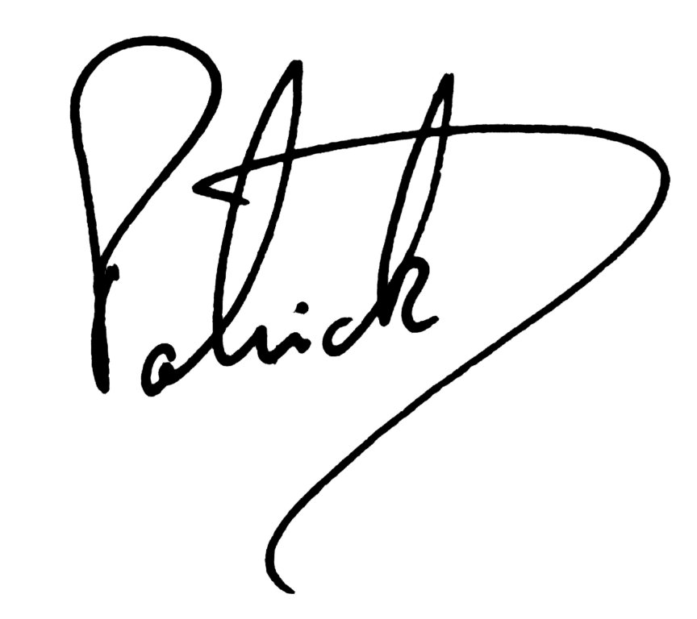

Patrick Mulvany

Chair, UK Food Group enc: World Food Day flyer and Seminar programme
UK Food Group, UK network for global food security
PO Box 100, London, SE1 7RL. Email: ukfg@ukfg.org.uk. URL: www.ukfg.org.uk



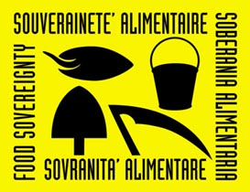

World Food Day @ ESF

No GMOs @ FAO
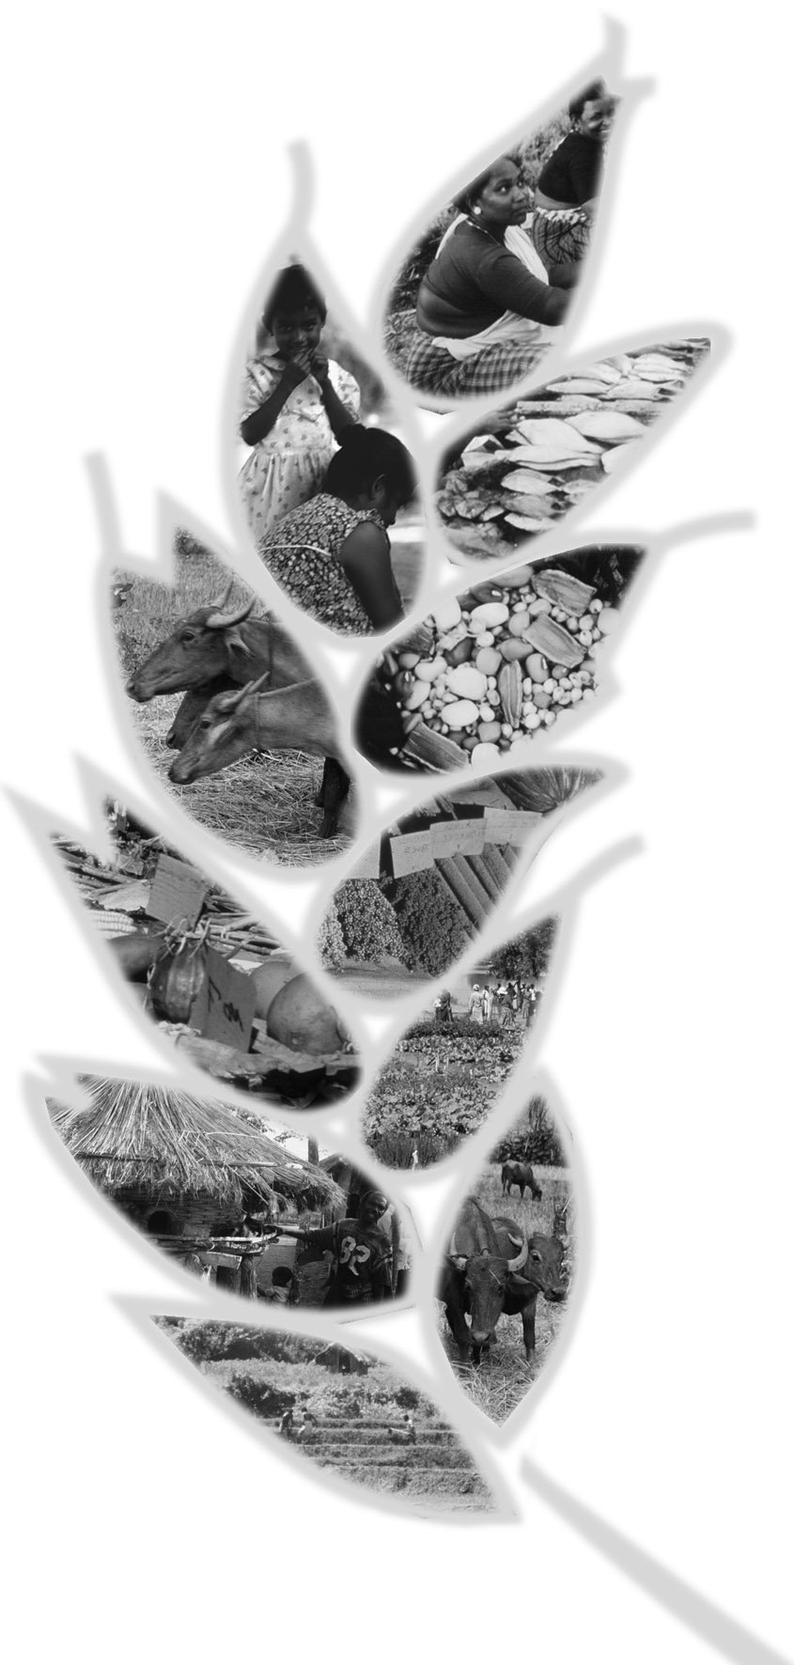


London, 16 October 2004
On World Food Day 2004 at the European Social Forum in London, speaker after speaker criticised FAO for promoting GM crops as a solution to hunger.
In the context of 840 million people going to bed hungry each night in a world with 1.5 billion overfed people that spends $900 billion a year on weapons and war;
- recognising the immense contribution of, presently highly threatened, smallholder and peasant farmers, pastoralists, fisherfolk, indigenous peoples and other natural resources users to the development and management of the freely accessible agricultural biodiversity that feeds the world;
- also recognising that this agricultural biodiversity, the first link in the food chain, is also threatened by contamination from proprietary genetically modified organisms controlled by Trans National Corporations;
- aware that investments in genetic engineering are skewing resources away from research in sustainable agroecological food production systems that can be developed and controlled by local farmers;
- recognising that European consumers and taxpayers have rejected GM crops and foods;
- and recognising that only through food sovereignty policies will the problems of hunger and poverty be addressed effectively;
Delegates unanimously supported the transmission of a clear and unambiguous message to FAO:
In solidarity with peasant and smallholder farmers’ organisations and joining the hundreds of organisations and social movements across the world that have already criticised FAO for the contents of its 2004 SOFA report on biotechnology, delegates at the European Social Forum 2004 World Food Day events condemn the Food and Agriculture Organisation of the United Nations (FAO) for promoting the development and use of genetically modified crops for eradicating poverty and hunger; and call on the FAO immediately to reject the agendas and the direct and indirect influences of Trans National Corporations in its normative and operational work; and to reorient all its efforts to tackling the root causes of hunger, promoting sustainable agroecological technologies and defending agricultural biodiversity.

UK Food Group: the UK network for global food security www.ukfg.org.uk

Coordination of the publicity of the World Food Day events at the European Social Forum was undertaken by the UK Food Group, which also co-sponsored two Seminars

