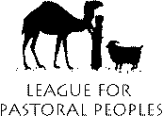
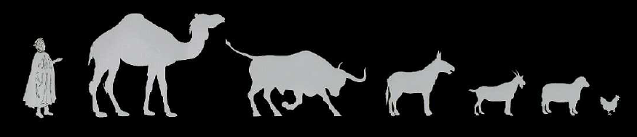
Leaders of Traditional Livestock and Pastoral Communities, government representatives, Civil Society Organizations with a focus on livestock genetic resources, academics and livestock researchers met in Karen, Kenya from 27 to 30 October, 2003.

They issued a statement as follows:

Karen Commitment
Pastoralist/Indigenous Livestock Keepers’ Rights

We call on governments and relevant international bodies to commit themselves to the formal recognition of the historical and current contribution of pastoralists and pastoralism to food and livelihood security, environmental services and domestic animal diversity.
We also demand that they recognise the contributions of pastoralists and other livestock keepers, over millennia, to the conservation and sustainable use of animal genetic resources for food and agriculture including associated species and the genes they contain (AnGRFA).
Furthermore, we insist that there is international legally-binding recognition of inalienable Livestock Keepers’ Rights and the Rights of their communities to:

- continue to use their knowledge concerning the conservation and sustain-able use of AnGRFA, without fears of its appropriation
- participate democratically in making decisions on matters related to the conservation and sustainable use of AnGRFA
- access, save, use, exchange, sell their AnGRFA, unrestricted by Intellectual Property Rights (IPRs) and [modification through] genetic engineering tech-nologies that we believe will disrupt the integrity of these genetic resources
- have their breeds recognised as products of their communities and Indigenous Knowledge and therefore remain in the public domain
- benefit equitably from the use of AnGRFA in their own communities and by others.
We call on the Food and Agriculture Organisation of the UN (FAO) to start negotiating such a legally-binding agreement, without delay, ensuring that it will be in harmony with the Convention on Biological Diversity.
We further call on the FAO to develop a Global Plan for the conservation and sustainable use of AnGRFA by pastoralists, other livestock keeping communities and relevant public institutions.
Finally, we insist that AnGRFA be excluded from Intellectual Property Rights claims and that there should be a moratorium on the release of genetically-modified livestock until bio-safety is proven, in accordance with the Precautionary Principle. We call on relevant institutions concerned with food, agriculture, trade, intellectual property and animal research to provide assurances and such legal protection as is necessary to sustain the free flow and integrity of AnGRFA, vital to global food security and the environment.
Workshop was supported by:




Statement is endorsed by:
LIFE
Local Livestock For Empowerment of Rural People

